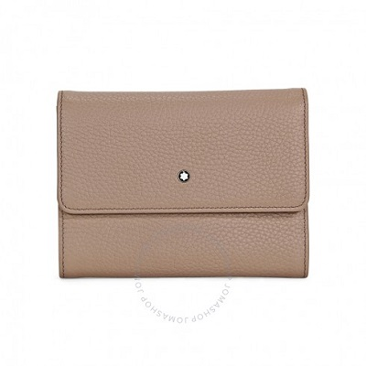

Montblanc Meisterstuck Beige Soft Grain Leather 6CC Wallet & Coin Case

PRODUCT DETAILS

**Montblanc Meisterstuck wallet 8cc wallet and coin case made of Italian beige soft-grain calfskin leather and jacquard (Montblanc logo) lining. Montblanc emblem**

**with palladium-coated ring. Internal Organization: 8 pockets for credit cards, 2 compartments for banknotes, a coin case with zip and 2 additional pockets.**

**Dimensions: 14.5 mm x 11 cm.**